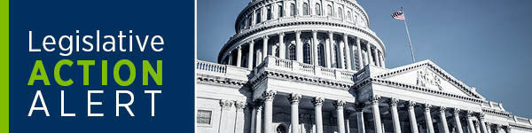
Dear AVMA Advocates,
As of July 7, 2020, over 18,500 veterinary practices took Paycheck Protection Loans to support their operations during the COVID-19 pandemic. Unfortunately, the IRS is prohibiting PPP borrowers from claiming federal tax deductions that are normally fully deductible - including some rent and utility payments, and wages and benefits paid to employees - for forgivable expenses paid with PPP funds. If this isn't reversed, veterinary small business owners could face an unanticipated additional tax burden.
The IRS action contradicts congressional intent, which was to allow for the deduction of eligible expenses under the PPP program. Fortunately, there is interest in both political parties in the House and Senate to address this issue with a legislative "fix", but we need your help to get it done. Please contact your Members of Congress and urge them to pass legislation to allow small businesses to take their eligible tax deductions as Congress intended when creating the PPP. Please personalize the email to let your Members know how this will impact your practice. We need everyone-practice owners, veterinary associates and practice staff -to take action so that veterinary practices can keep what they earn and use those funds to pay for operating expenses during these difficult times.
Thank You,
AVMA Advocacy Team
Take Action

Copyright (C) American Veterinary Medical Association| Privacy

